**Exercise: Playbooks - Lookup**

1. Verify that your ansible installation is available by displaying the version of ansible while logged in as the 'user' user.

[test@tcox3 ~]$ ansible --version

ansible 1.9.2

  configured module search path = None

2. Run the ansible command that lists all of the hosts configured in your control server 'hosts' file for the system.

[test@tcox3 ~]$ ansible all --list-hosts

    tcox5.mylabserver.com

    localhost

    tcox4.mylabserver.com

3. Create a playbook, using the 'LOOKUP' concepts from the video:

- Uses SSH

- Logs in to the remote system as 'test' user

- Connects to one server or group from Step #2 above

- The playbook runs as 'sudo'

- Skip gathering remote facts

- Display a JSON formatted debug message that will show the remote environment HOME variable

[test@tcox3 Playbooks]$ vim lookup.yml   
[test@tcox3 Playbooks]$ cat lookup.yml   
--- # LOOKUP PLAYBOOK EXAMPLE  
- hosts: apacheweb  
  user: test  
  sudo: yes  
  connection: ssh  
  gather_facts: no  
  tasks:  
    - debug: msg="{{ lookup('env','HOME') }} is the value listed"

4. Run the playbook and display the results.

[test@tcox3 Playbooks]$ ansible-playbook lookup.yml   
  
PLAY [apacheweb] **************************************************************   
  
TASK: [debug msg="/home/test is the value listed"] ****************************   
ok: [tcox4.mylabserver.com] => {  
    "msg": "/home/test is the value listed"  
}  
  
PLAY RECAP ********************************************************************   
tcox4.mylabserver.com      : ok=1    changed=0    unreachable=0    failed=0

Lab :

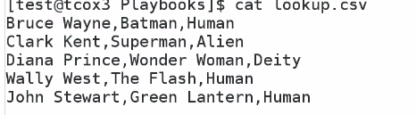

Ansible built in function that allow to look up file ,env

Show information

LAB:



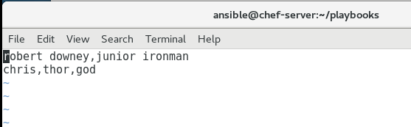

Lookup csv file

--- #LooKUP PLAYBOOK EXAMPLE

- hosts: local

user: ansible

sudo: yes

connection: ssh

gather_facts: no

tasks:

- debug: msg="{{ lookup('csvfile','chris file=lookup.csv delimiter=, default=NOMATCH') }} is the value listed"

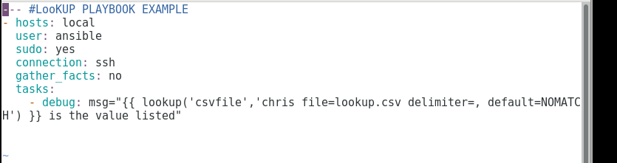

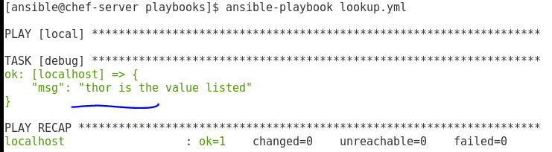

LAB 2:

Lookup env variable

